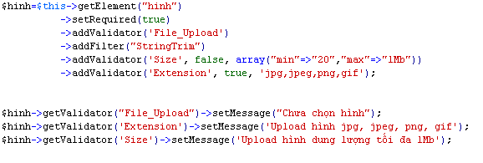
$hinh->setDestination(APPLICATION_PATH.'/../public/images');

